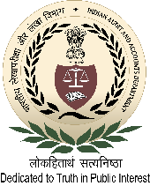
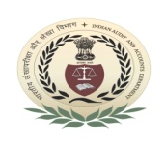
International Centre for Information Systems and Audit (iCISA)

A-52, Sector - 62, Institutional Area, Noida - 201307

Course Schedule
National Training Programme on
“IT Audit”
[for the officers of O/o the Principal Director of Audit(E&SM), New Delhi]
13 – 14 May, 2019

Registration: 09:30 AM - 09:45 AM (at Room no.111) on 13 May 2019
Date and Day | Session - I  (10:00 AM to 11.15 AM) | Session - II  (11:45 AM to 01.00 PM) | Session - III  (02:00 PM to 03.15 PM) | Session - IV  (03.45 PM to 05:00 PM)
13 May 2019  (Monday) | Overview of IT Audit | Planning IT Audit and Audit Design Matrix | Risk Assessment in IT Audit | Taking Dump of SQL Server/ DB2 and restoring the same
Faculty/Speaker | Mr. Abhay Singh  Deputy Director | Mr. K.P. Singh, SAO | Mr. K.P. Singh, SAO | Mr. Sekharesh Sen, SAO
 | Room no. 213 |  |  | Room no. 111
14 May 2019  (Tuesday) | Understanding IT controls  (SoDs, operational controls, access and environment controls, change controls and application controls), |  | Understanding BCP and DRP, Audit concerns of Information security and Development and Acquisition, and Evaluation
Faculty/Speaker | Mr. K.P. Singh, SAO |  | Mr. K.P. Singh, SAO
 | Room no. 213

Tea/Coffee Break: 11:15 AM - 11:45 AM Lunch: 01:00 PM - 02:00 PM Tea/Coffee Break: 03:15 PM - 03:45 PM

